Lab SHEET 02
HIMANI CHAUDHARY , CU240250967 , SEC(B), ROLL NO. 24
: Making It Interactive (Vanilla JavaScript)
<!DOCTYPE html>
<html lang="en">

<head>
<meta charset="UTF-8">
<meta name="viewport" content="width=device-width, initial-scale=1.0">

<title>My E-Commerce Store</title>

<link rel="stylesheet" href="style.css">
</head>

<body>

<nav>

<h2>My Store</h2>

<div>
<a href="index.html">Home</a>

<a href="products.html">Products</a>

<a href="cart.html">
Cart
<span id="cart-count">0</span>
</a>

<a href="checkout.html">Checkout</a>
</div>

</nav>

<section class="hero">

<h1>Welcome to My E-Commerce Store</h1>

<p>Buy your favorite products at the best prices.</p>

<a href="products.html">
<button>Shop Now</button>
</a>

</section>

<script src="script.js"></script>

</body>

</html>
<!DOCTYPE html>
<html lang="en">

<head>

<meta charset="UTF-8">

<meta name="viewport" content="width=device-width, initial-scale=1.0">

<title>Products</title>

<link rel="stylesheet" href="style.css">

</head>

<body>

<nav>

<h2>My Store</h2>

<div>

<a href="index.html">Home</a>

<a href="products.html">Products</a>

<a href="cart.html">
Cart
<span id="cart-count">0</span>
</a>

<a href="checkout.html">Checkout</a>

</div>

</nav>

<h1 class="page-title">
Our Products
</h1>

<!-- JavaScript will add products here -->

<div id="product-container" class="product-container">
</div>

<script src="script.js"></script>

</body>

</html>

<!DOCTYPE html>
<html lang="en">

<head>

<meta charset="UTF-8">

<meta name="viewport" content="width=device-width, initial-scale=1.0">

<title>Shopping Cart</title>

<link rel="stylesheet" href="style.css">

</head>

<body>

<nav>

<h2>My Store</h2>

<div>

<a href="index.html">Home</a>

<a href="products.html">Products</a>

<a href="cart.html">
Cart
<span id="cart-count">0</span>
</a>

<a href="checkout.html">Checkout</a>

</div>

</nav>

<h1 class="page-title">
Shopping Cart
</h1>

<div id="cart-container" class="cart-container">
</div>

<h2 id="cart-total">
Total: ₹0
</h2>

<a href="checkout.html">
<button>Proceed to Checkout</button>
</a>

<script src="script.js"></script>

</body>

</html>

<div>
<h3>${item.name}</h3>

<p>Price: ₹${item.price}</p>

<label>
Quantity:
<input
type="number"
min="1"
value="${item.quantity}"
onchange="updateQuantity(${item.id}, this.value)"
>
</label>

<button onclick="removeFromCart(${item.id})">
Remove
</button>
</div>

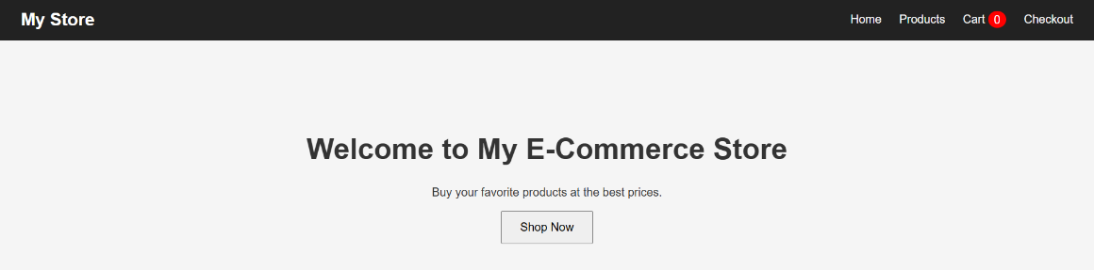

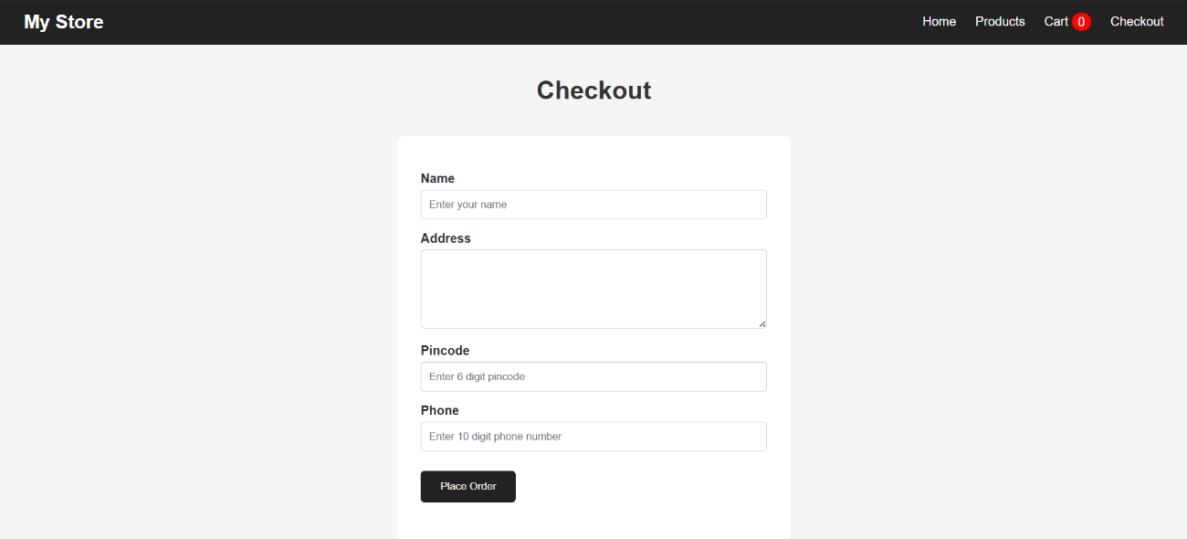
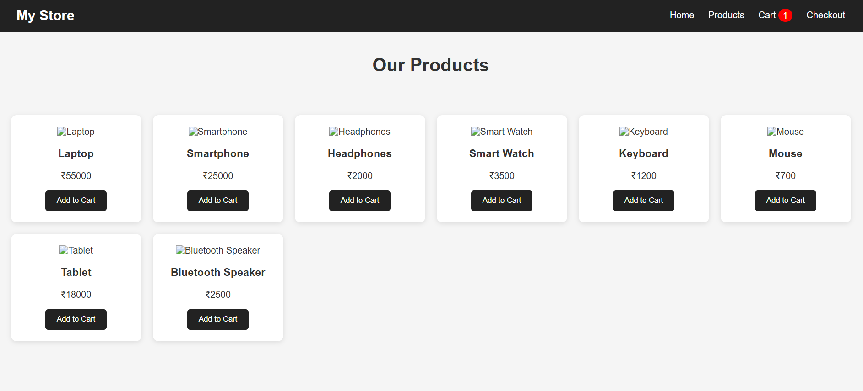

* {
box-sizing: border-box;
}

body {
margin: 0;
font-family: Arial, sans-serif;
background: #f5f5f5;
color: #333;
}

/* NAVBAR */

nav {
background: #222;
color: white;
padding: 15px 40px;
display: flex;
justify-content: space-between;
align-items: center;
}

nav h2 {
margin: 0;
}

nav a {
color: white;
text-decoration: none;
margin-left: 20px;
}

#cart-count {
background: red;
padding: 3px 8px;
border-radius: 50%;
}

/* HERO */

.hero {
text-align: center;
padding: 100px 20px;
}

.hero h1 {
font-size: 40px;
}

.hero button {
padding: 12px 25px;
font-size: 16px;
}

/* PAGE TITLE */

.page-title {
text-align: center;
margin: 40px;
}

/* PRODUCTS */

.product-container {
display: grid;
grid-template-columns: repeat(auto-fit, minmax(220px, 1fr));
gap: 20px;
padding: 30px;
}

.product-card {
background: white;
padding: 20px;
text-align: center;
border-radius: 10px;
box-shadow: 0 2px 8px rgba(0, 0, 0, 0.1);
}

.product-card img {
width: 180px;
height: 150px;
object-fit: cover;
}

.product-card button {
background: #222;
color: white;
border: none;
padding: 10px 20px;
cursor: pointer;
border-radius: 5px;
}

.product-card button:hover {
background: #444;
}

/* CART */

.cart-container {
padding: 30px;
}

.cart-item {
background: white;
padding: 20px;
margin-bottom: 20px;
display: flex;
gap: 20px;
align-items: center;
border-radius: 10px;
}

.cart-item img {
width: 120px;
height: 100px;
object-fit: cover;
}

.cart-item input {
width: 70px;
padding: 8px;
}

.cart-item button {
background: red;
color: white;
border: none;
padding: 8px 15px;
cursor: pointer;
}

#cart-total {
text-align: center;
margin: 30px;
}

/* CHECKOUT FORM */

form {
width: 500px;
max-width: 90%;
margin: auto;
background: white;
padding: 30px;
border-radius: 10px;
}

form label {
display: block;
margin-top: 15px;
font-weight: bold;
}

form input,
form textarea {
width: 100%;
padding: 10px;
margin-top: 5px;
border: 1px solid #ccc;
border-radius: 5px;
}

form textarea {
height: 100px;
}

form button {
margin-top: 20px;
padding: 12px 25px;
background: #222;
color: white;
border: none;
cursor: pointer;
border-radius: 5px;
}

/* ERRORS */

.error {
color: red;
font-size: 14px;
margin: 5px 0;
}

/* SUCCESS */

.success {
color: green;
}

